For other Data analytics projects, follow this github link - <https://github.com/ManukrishnanBS/Analytics>

DATA ANALYSIS USING EXCEL

In this project, I am going to analyze the Air Quality Index dataset which was downloaded from [Kaggle](https://www.kaggle.com/rohanrao/air-quality-data-in-india) (<https://www.kaggle.com/rohanrao/air-quality-data-in-india>). The dataset contains the air quality data and AQI (Air Quality Index) at hourly and daily level of various stations across multiple cities in India. There are individual components like PM2.5, NO, PM10 etc., the weighted values of which contribute to the overall figure of AQI. AQI Bucket groups the cities into six categories based on their AQI value : Good (0-50), Satisfactory (51-100), Moderate (101-200), Poor (201-300), Very Poor (301-400), Severe (> 401).

Below is a snapshot of the data set,



Grouping data using Pivot table

I have tabulated the average AQI of the cities across the years. In the snapshot below we can see the average AQI calculated for all the cities per year from 2015 to 2020.

In order to compare the AQI values of cities, we can use a Pivot chart. It can be seen that the AQI value of Ahmedabad has been consistently on the higher side every year.

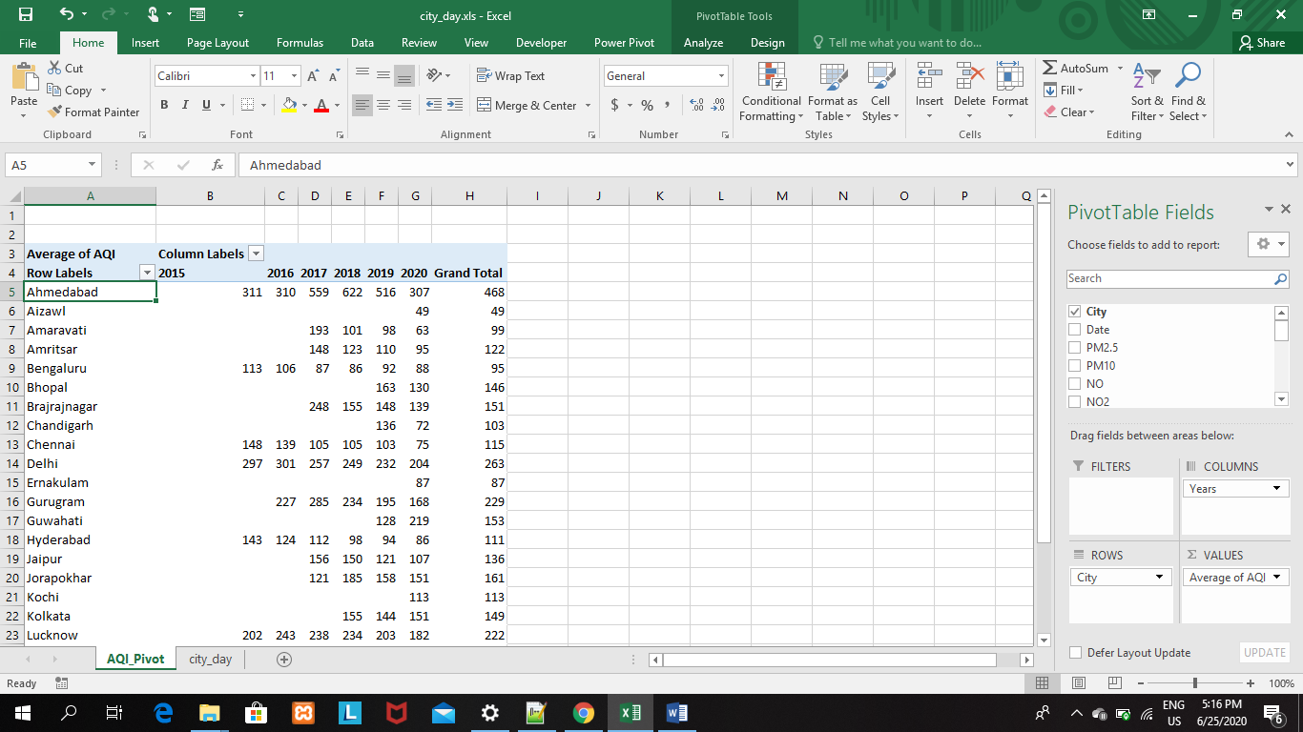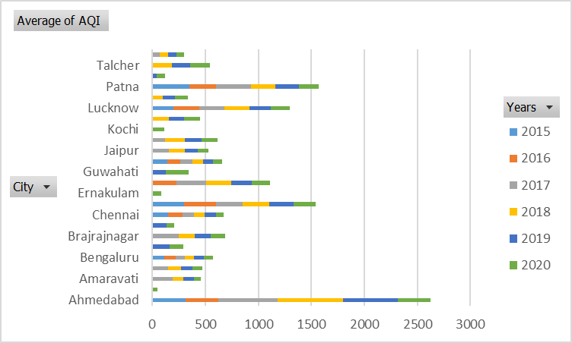

I went on to create a few more pivot charts and then created a dashboard as shown below using all those pivot charts. Slicers for Year, AQI bucket and City were added to the dashboard. The dashboard has pivot charts depicting the average AQI trendline, count of AQI bucket (which tells us the category which was prevalent in any particular city in any given year or over a period of time).

